1. Vocabulary
2. Backpack
3. Slogan
4. Frighten
5. Hire
6. Harmony
7. Human
8. Peaceful
9. Retire
10. Stressful
11. Thunder
12. Atmosphere
13. Brilliant
14. Colleague
15. Disappointed
16. Express
17. Memories
18. Performer
19. Platform
20. Poem
21. Security
22. Grammar
23. Quantifier:
24. Many/Much/A lot of

>>> We use *much* with singular uncountable nouns and *many* with plural nouns:

1. [talking about money]
2. *I haven’t got****much****change. I’ve only got a ten euro note.*
3. *Are there****many****campsites near you?*
4. Some/Any
5. A few/ A little

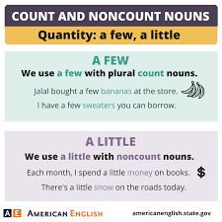

1. Comparative and Superlative

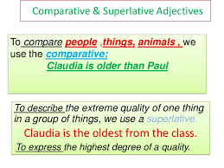

1. Present Simple and Present Continuous
2. Past simple and Present perfect
3. 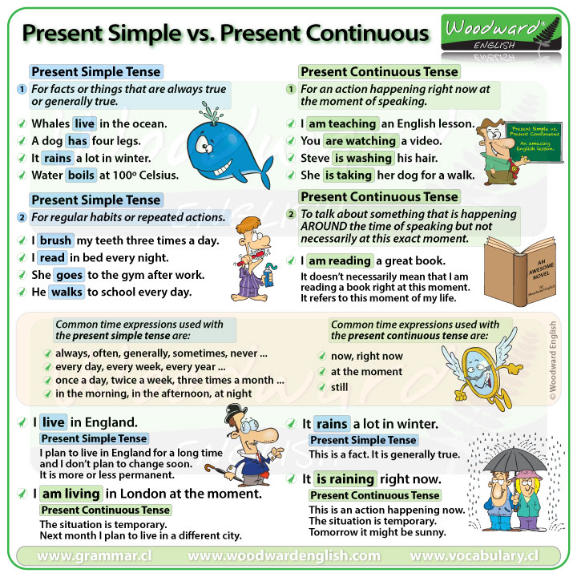Reading
4. 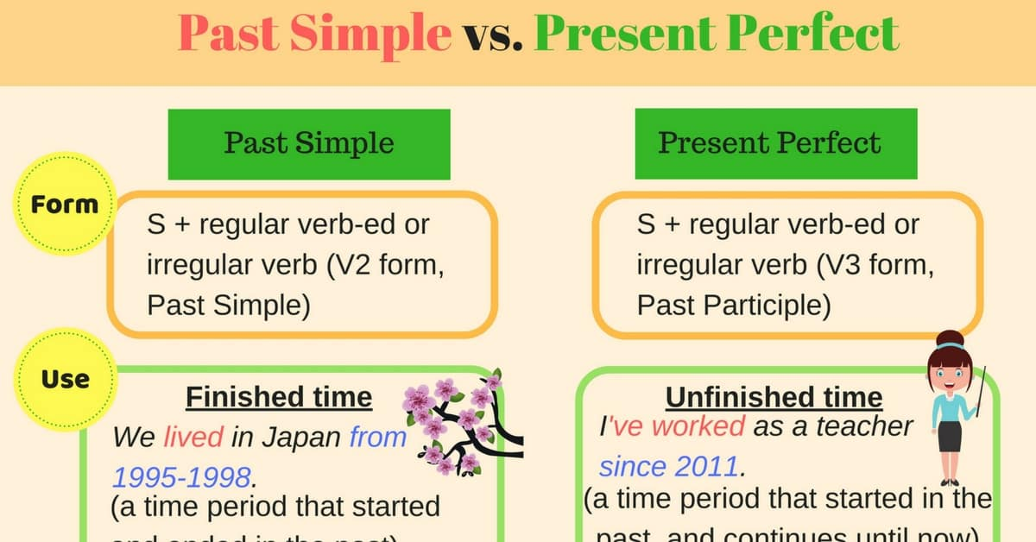One article
5. Multiple choices
6. True/Fales
7. Writing
8. 3 topics given
9. Students choose one topic and write as a paragraph between 120 to 150 words.